**Surface Representation and Morphometric Analysis Based on Discrete Cosine Transform**

Bingjue Li1*, Shengmin Zhou2*, Heng Nie1

1 School of Mechanical Engineering and Jiangsu Key Laboratory for Design and Manufacture of Micro/Nano Biomedical Instruments, School of Mechanical Engineering, Southeast University, Nanjing, Jiangsu, 211189, China.

2 OPPO Mobile Telecommunications Co., Ltd., No. 158, Tianfu Fourth Street, Chengdu High-Tech Zone, Chengdu, Sichuan, 610000, China.

* Corresponding authors: [libj@seu.edu.cn](mailto:libj@seu.edu.cn) (Bingjue Li); [2495077522@qq.com](mailto:2495077522@qq.com) (Shengmin Zhou)

This supplementary material includes additional information for 1) the results obtained with *all* coefficients reserved, and 2) the results obtained with *algorithms determined* paths that are not provided in the man text.

# Results with all coefficients reserved

The fitting result of the simulated surfaces with all 110 harmonics has already been presented in Fig. 10f (the 1st sample is illustrated as an example), thus is omitted here. Shape reconstructions of the skull surfaces with all harmonics are illustrated in Fig. S1. It can be observed that the fitting curve coincides all the points that define the surface in all examples.

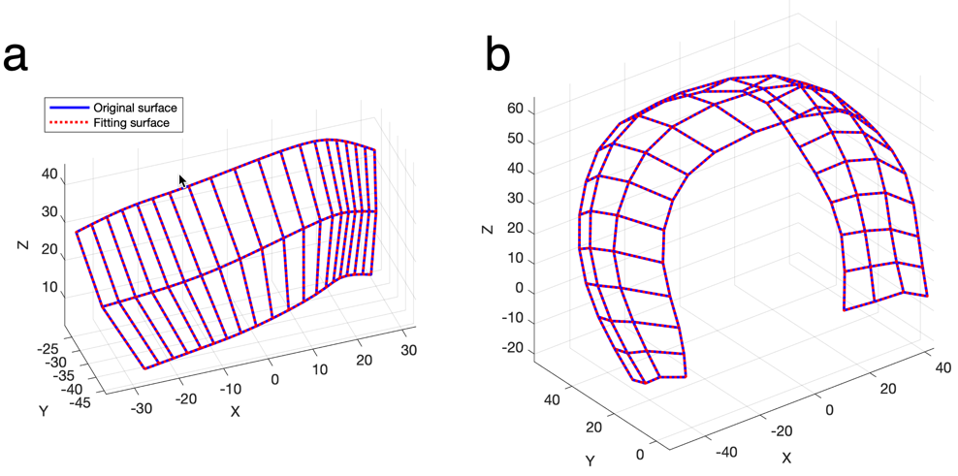

**Figure S1.** Matching (**a**) skull surface 1 with 60 harmonics and (**b**) skull surface 2 with 80 harmonics. The surfaces are represented by the manually determined paths as shown in Fig. 7. The 1st sample (LUCS) is illustrated.

# Results using path determined by algorithms

Here, we present the shape representation and analysis results with the traversing paths figured out by GA and ACA. The parameter settings in GA and ACA can be found in the code we supplied (see TSPGA.m and ACATSP.m under the folder “GA_and_ACA”), and are also presented as follows.

GA:

maxGEN = 1000; % Maximum number of iterations

popSize = 200; % GA group size

crossoverProbabilty = 0.8; % Probility of crossover

mutationProbabilty = 0.2; % Probility of mutation

ACA:

iter_max=200; % Maximum Iterrations

m=60; % The number of ants

Alpha=1; % Parameters characterizing the importance of pheromones

Beta=5; % Parameters characterizing the importance of heuristic factors

Rho=0.7; % Pheromone evaporation factor

Q=20; % Pheromone increase intensity factor

**The simulated surfaces**

Here, the traversing paths are figured out by GA and ACA based on the 1st sample (Group 1).

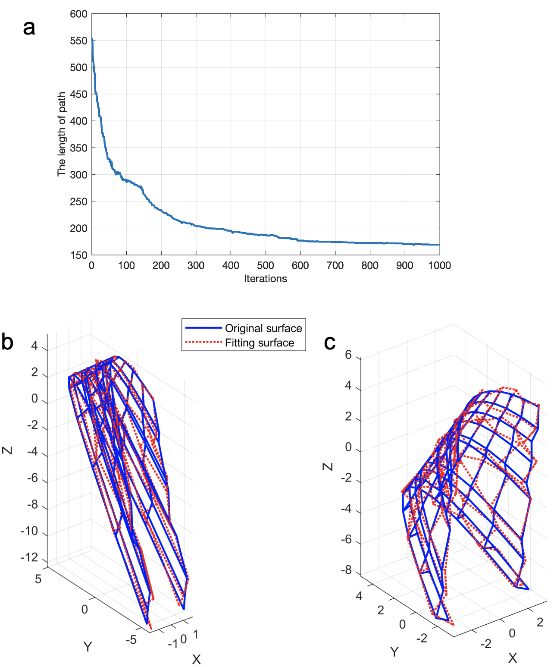

**Figure S2.** The traversing path determined with GA after 1000 iterations and shape reconstruction using 97 harmonics for the simulated surfaces. (**a**) The total length of the path at each iteration; (**b**) The best match (the 1st surface, belonging to Group 1, *re*1 = 0.0774); (**c**) The worst match (the 65th surface, belonging to Group 3, *re*65 = 0.3510).

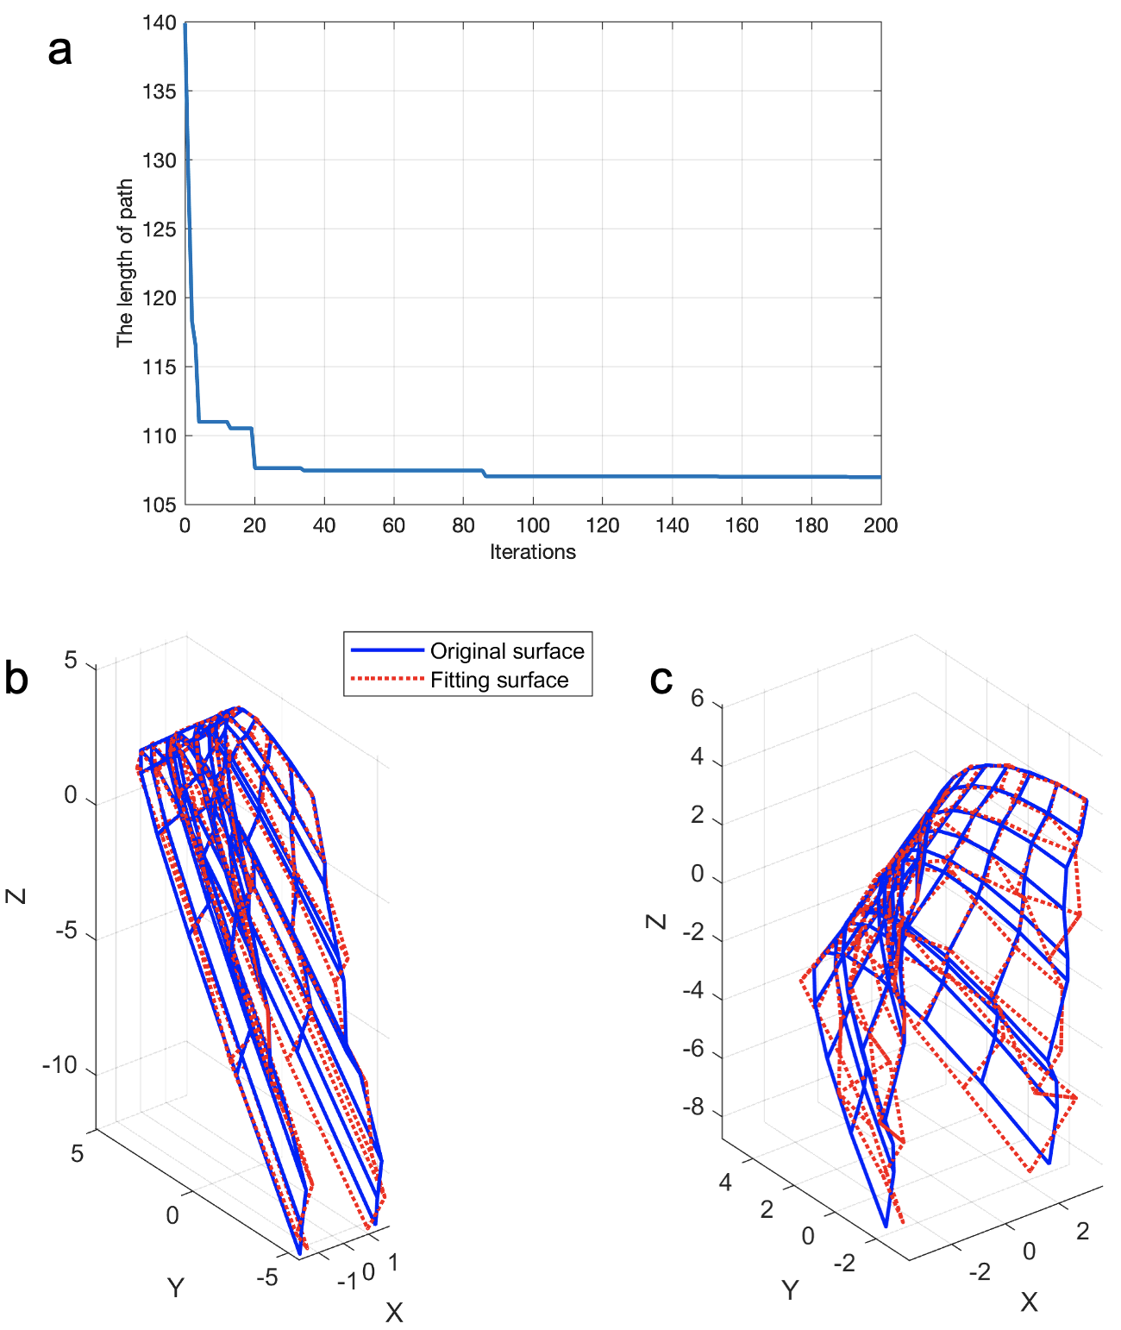

**Figure S3.** The traversing path determined with ACA after 200 iterations and shape reconstruction using 87 harmonics for the simulated surfaces. (**a**) The total length of the path at each iteration; (**b**) The best match (the 1st surface, belonging to Group 1, *re*1 = 0.0394); (**c**) The worst match (the 62nd surface, belonging to Group 3, *re*65 = 0.2815).

**Surfaces extracted from 3D children skulls**

Here, the traversing paths are figured out by GA and ACA based on the 1st sample (LUCS).

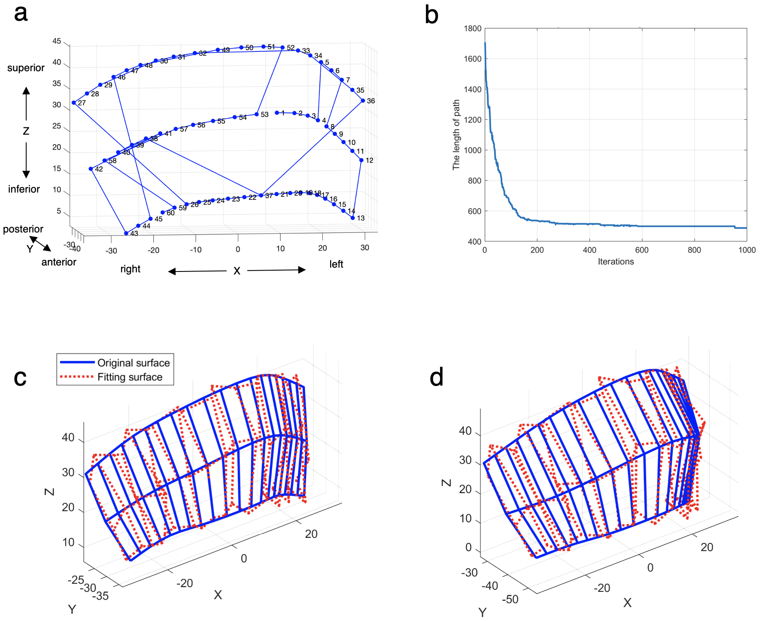

**Figure S4.** The traversing path determined with GA after 1000 iterations and shape reconstruction using 38 harmonics for skull surface 1. The paths determined for 1st sample (LUCS) of skull surface 1 and the corresponding lengths are presented as an example. (**a**) The path figured out with GA; (**b**) The length of the path at each iteration; (**b**) The best match (the 41st surface, BCS, *re*41 = 5.5617); (**c**) The worst match (the 57th surface, unaffected, *re*57 = 10.5358).

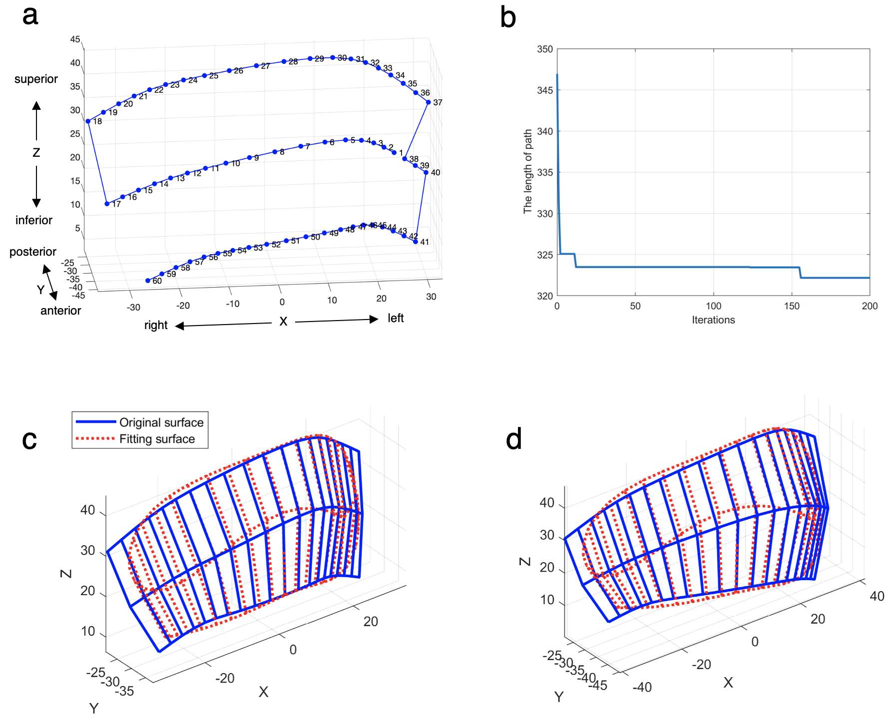

**Figure S5.** The traversing path determined with ACA after 200 iterations and shape reconstruction using 9 harmonics for skull surface 1. The paths determined for 1st sample (LUCS) of skull surface 1 and the corresponding lengths are presented as an example. (**a**) The path figured out with ACA; (**b**) The length of the path at each iteration; (**b**) The best match (the 41st surface, BCS, *re*41 = 7.4278); (**c**) The worst match (the 42nd surface, RUCS, *re*42 = 14.7605).

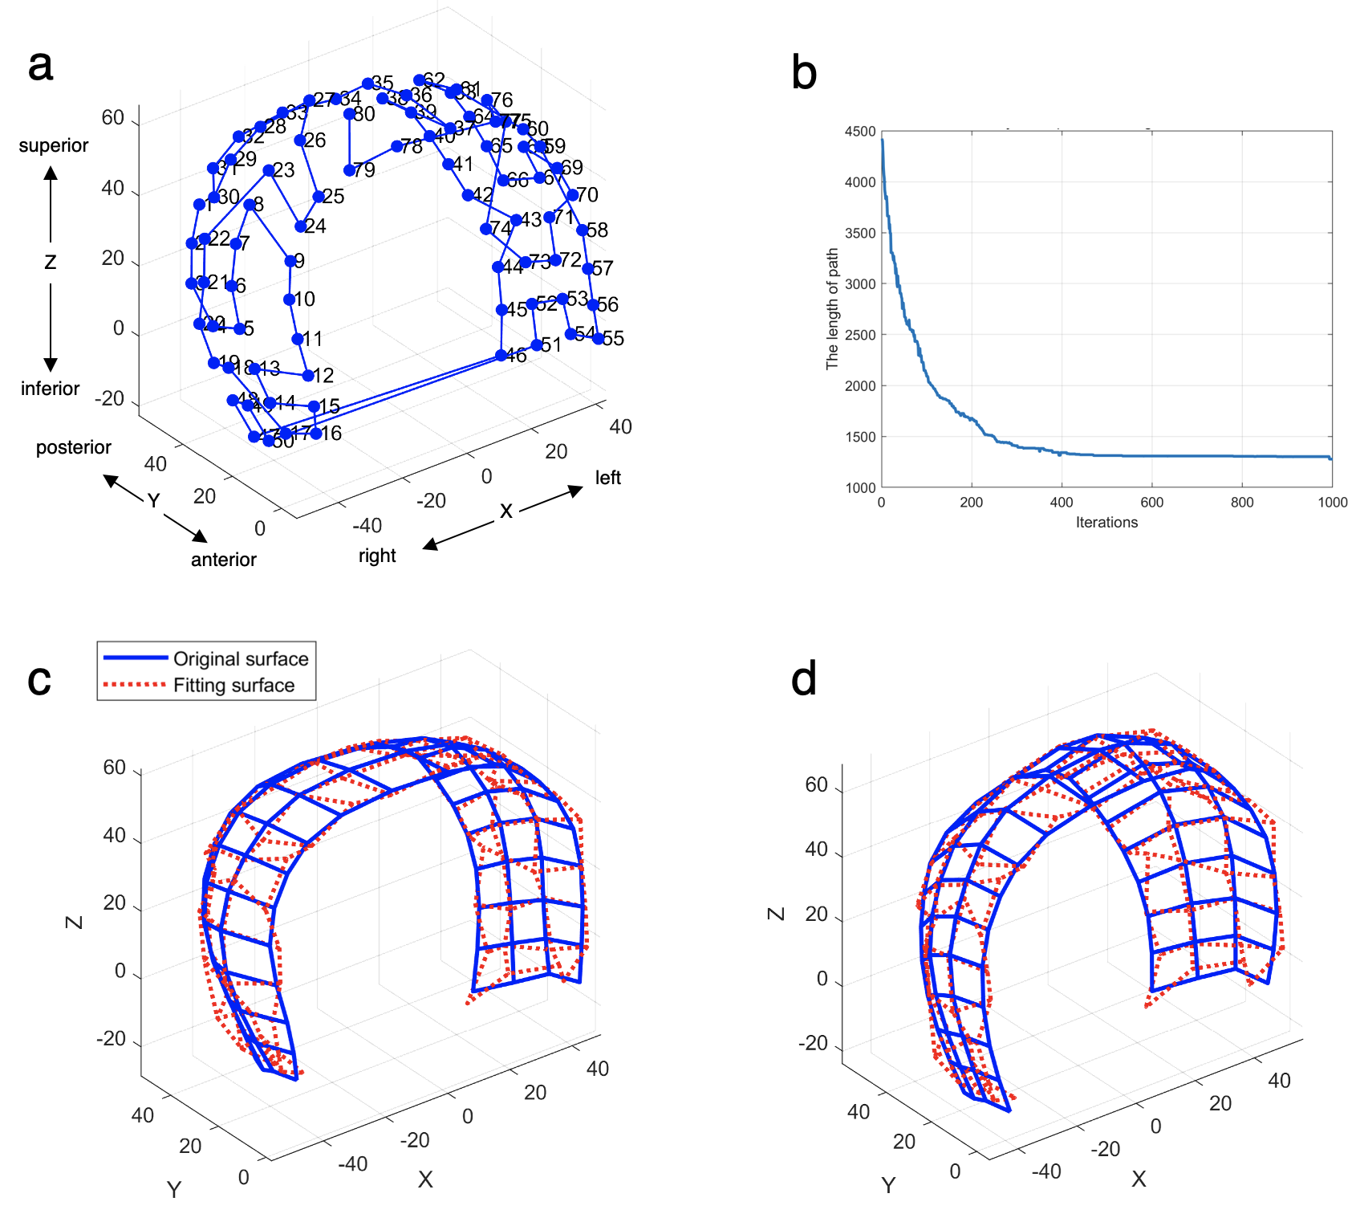

**Figure S6.** The traversing path determined with GA after 1000 iterations and shape reconstruction using 58 harmonics for skull surface 2. The paths determined for 1st sample (LUCS) of skull surface 2 and the corresponding lengths are presented as an example. (**a**) The path figured out with GA; (**b**) The length of the path at each iteration; (**b**) The best match (the 9th surface, LUCS, *re*9 = 10.4992); (**c**) The worst match (the 30th surface, RUCS, *re*30 = 13.6096).

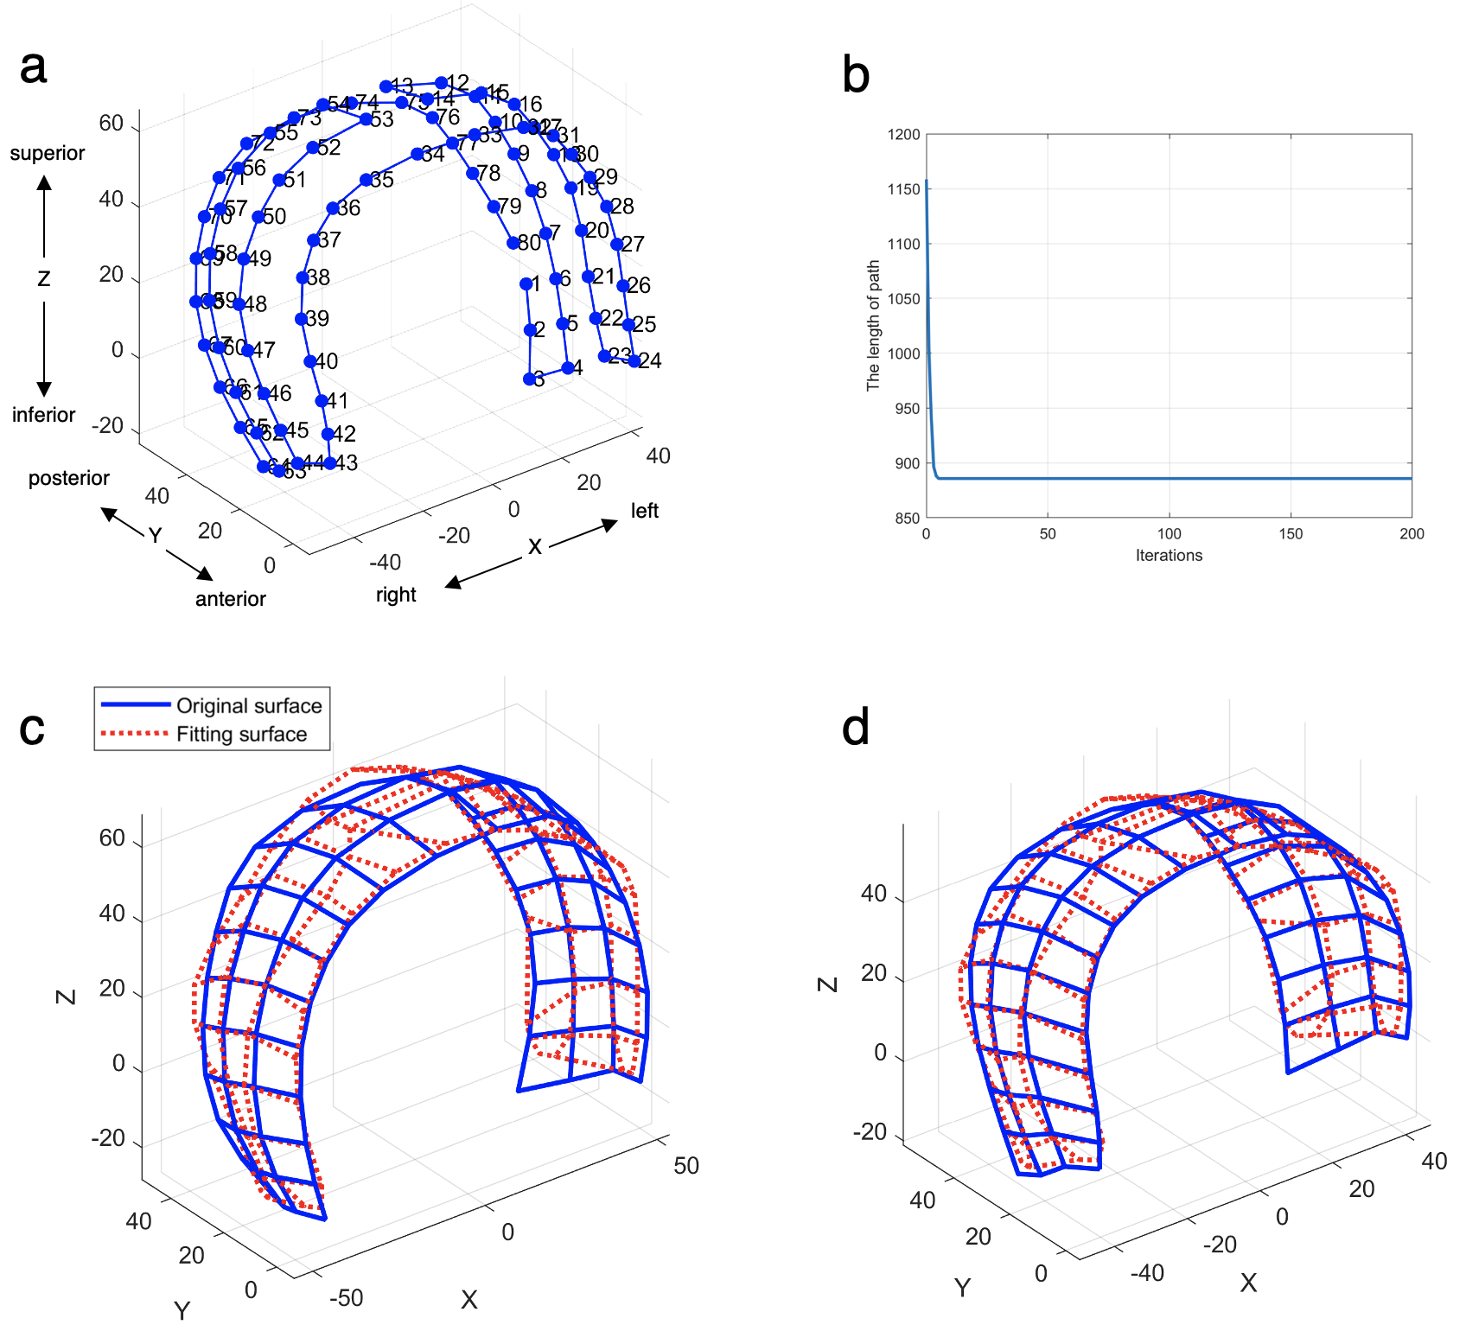

**Figure S7.** The traversing path determined with ACA after 200 iterations and shape reconstruction using 20 harmonics for skull surface 2. The paths determined for 1st sample (LUCS) of skull surface 2 and the corresponding lengths are presented as an example. (**a**) The path figured out with ACA; (**b**) The length of the path at each iteration; (**b**) The best match (the 49th surface, unaffected case, *re*49 = 12.9850); (**c**) The worst match (the 32nd surface, BCS, *re*32 = 17.0905).